AGENCY

Protected Utility

AGENCY - SOP - Apple BYO Device - User
 | 
Date 22 September 2020

Document Information

Document Acceptance for v1.0
Function | Date | Name | Position
Prepared: | 14-09-2020 |  | Consultant
Review | 30-09-2020 |  | AGENCY
Release | 01-10-2020 |  | Managing Consultant

Drafting and Release History
Version | Date | Author | Description
0.1 | 14-09-2020 |  | Initial Document
0.2 | 21-09-2020 |  | Review and update
1.0 | 22-09-2020 |  | Release
1.1 | 30-09-2020 |  | Review
1.2 | 01-10-2020 |  | Review update
1.3 | 01-10-2020 |  | Release

oobe contact details | oobe Pty Ltd
oobe contact details | | www.oobe.com.au  | GPO 111 Canberra City 2601  | ACN 123 977 846  | ABN 48 123 977 846

Contents
Setup Corporate iOS Device 4
Introduction 4
Purpose 4
Audience 4
Pre-Requisites 4
Enrolment 5

Setup Corporate iOS Device

Introduction
The AGENCY offer users a way to access corporate email using their personal devices.

Purpose
This document is to guide a user through the onboarding process for personal iOS devices.

Audience
AGENCY end users

Pre-Requisites
- The user has been added to the Azure Active Directory group ‘grp-Mobile-BYOD-Users’

Enrolment
Step | Instruction | Screen Shot
 | Open the App Store | 
 | Get the app Intune Company Portal | 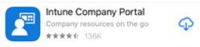
- . | The user will then need to sign into their AGENCY email address and NGD password | 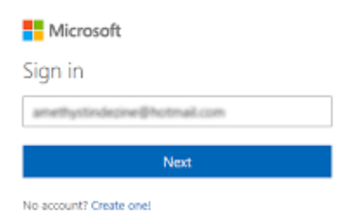
 | Select Begin | 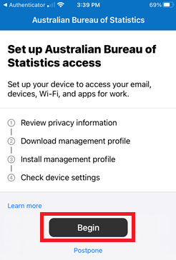
 | Download the management profile | 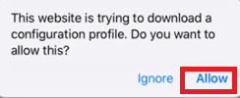
 | Select Close | 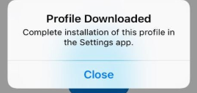
 | Select Continue now | 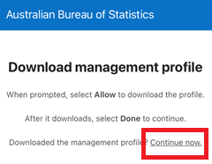
 | Select Continue | 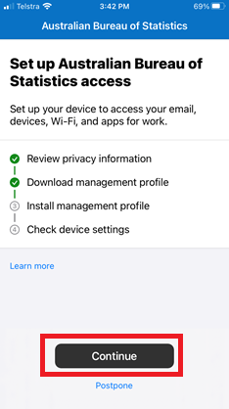
 | Open settings and select Profile Downloaded | 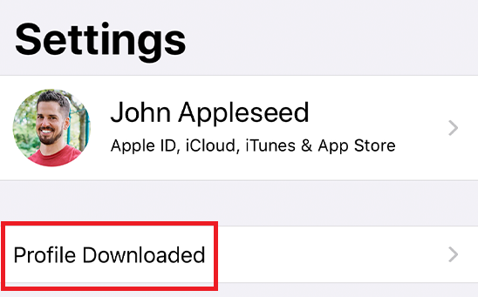
 | Select Install | 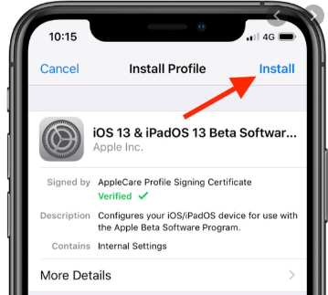
 | The user will be presented with a warning screen, select Install | 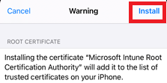
 | When prompted select Trust | 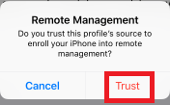
 | Select done | 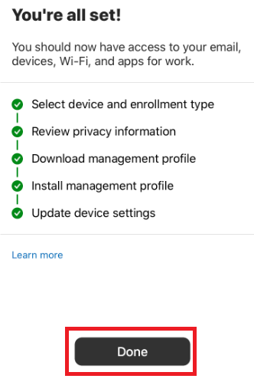
 | Once the user has signed into the company portal they will be able to access company managed applications.  From the App Store select and install Outlook | 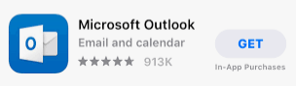
 | The user’s AGENCY email account will be automatically discovered by Outlook. Select Add Account | 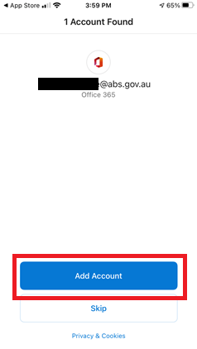
 | Open Outlook and sign in to your AGENCY account using your AGENCY email and NGD password | 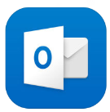
 | The user will be asked to set a password if their current one is not strong enough  Select Custom Alphanumeric Code and then enter a passcode that meets the following conditions:  - 10 characters long  - 1 uppercase letter  - 1 lowercase letter  - 1 special character  - 1 number | 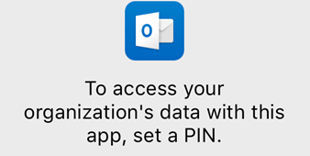
 | The user will now be able to access their corporate email account.

